Athens-Limestone Co.

Family Resource Center

**Strengthening Limestone County Families.**

The Athens-Limestone County Family Resource Center (ALCFRC) is dedicated to helping families find success by providing guidance, information, and personal mentoring. We are passionate about improving the quality of life for all residents in our community.

**2023 ANNUAL REPORT**

**CHARTER:**

The Athens-Limestone County Family Resource Center (ALCFRC) is a not-for-profit agency founded in 2007 to strengthen Limestone County families and help them move toward healthy self-sufficiency. Today, the Athens-Limestone Family Resource Center stands as a viable resource in the community for families in need.

**MISSION:**

To strengthen Limestone County families and support child safety and development through life-changing programs and services.

**TAG LINE:**

Strengthening Limestone County Families.

**VISION STATEMENT:**

Every family in Limestone County be given an opportunity to thrive.

**VALUES STATEMENT:**

**Faith**… We have full faith and confidence in the human spirit to overcome adversity especially when guided and supported by the community. It is our honor to be the connection between those in need and those who can guide to foster deeper family foundations.

**Respect**… We respect the dignity of each person and family we serve ­­— protecting their privacy, providing appropriate services in a timely manner, and listening with an open heart. We respect our colleagues and volunteers — collaborating through positive activities and communications. We respect other non-profits, government agencies, and businesses as they share their resources and expertise to build stronger Limestone County families.

**Cooperative and Collaborative**… These relationships strengthen our families and therefore our community. We welcome constructive input, volunteers of all ages and abilities, partnerships with service-driven organizations and other forms of community support. We are engaged with local civic organizations, non-profits, and churches as we keep pace with social and economic conditions.

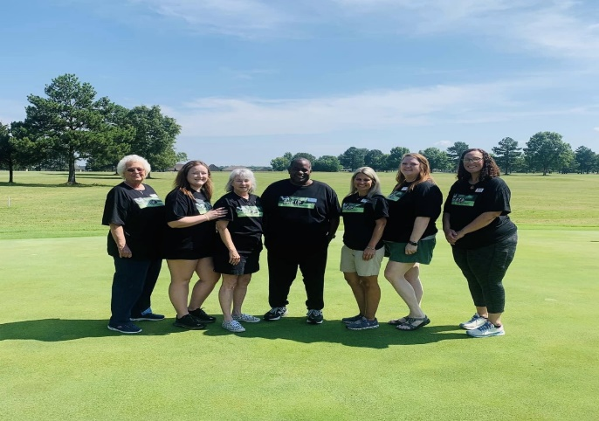

**ALCFRC Staff and Programs**

Our facility is open to serve Athens-Limestone County residents Monday through Friday 8:30 am to 4:30 pm. Our staff includes (4) full-time and (2) part-time employees, and (2) TARCOG employees. In addition, many volunteers & interns help us fulfill our mission. *Since 2010, we have impacted approximately 25,000 lives!*

Our services include Family Solutions, Family Ramp, Workforce Development, Dolly Parton Imagination Library, Project Smile, Project Game Changers, Families Assistance Through Community Ties (FACT) and Shepherd’s Closet. We hope to add Limestone County’s Families First Program (parenting/fatherhood) soon.

|  |  |  |  |
| --- | --- | --- | --- |
| ***GENERAL OVERALL NUMBERS*** | | | |
|  | **July 2021 to June 2022** | **July 2022 to June 2023** | **July 2023 to June 2024** |
| Sign-Ins and Calls Logged* | 9,448 | 9,454 | 10,318 |
| Volunteer Hours | 2,341 | 2,271 | 2,332 |
| Households Served | 674 | 732 | 3,512 |
| Children Served | 517 | 593 | 1,191 |
| Family Solutions Program Appt.*** | 527 | 401 | 1,030 |
| Wheelchair Ramps Built | 25 | 29 | 20 |
| *\*This number includes only Participants who signed in &/or that we noted on phone log* | | | |
| *\*\*\*This number includes only Participants who showed up for their appointment* | | | |

**Our records also include the following number of appointments during the July 2023-June 2024 span:**

|  |  |  |  |
| --- | --- | --- | --- |
| 3 Pastoral Counseling | 4 Financial Counseling | 175 Financial Class Participants |  |

**Local Partnerships & Supporters**

ALCFRC partnerships with the Limestone County Commission, City of Athens, United Way of Athens-Limestone County, Alabama Network of Family Resource Centers and numerous local churches ensure that our doors are open to serve residents. Without this funding, we would not be able to focus our attention on making an impact in the lives of families and future generations. Your generosity along with the entities mentioned above provide us with the ability to focus on helping people become stable, productive, useful members of the Athens-Limestone County community.

|  |  |  |  |
| --- | --- | --- | --- |
| ***LOCAL OPERATIONAL FUNDING SUPPORT*** | | | |
|  | **July 2021 to June 2022** | **July 2022 to June 2023** | **July 2023 to June 2024** |
| Limestone Co. Com mission | $20,000 (+ utilities) | $20,000 (+ utilities) | $25,000 (+ utilities) |
| City of Athens | $20,000 | $20,000 | $20,000 |
| United Way of Athens-Limestone County | $20,000 | $15,000 | $12,500 |
| Local Churches | $34,534 | $20,500 | $17,500 |
| ANFRC (Circle of Care) |  | $10,090 | $10,500 |

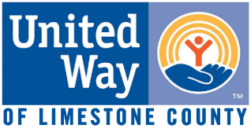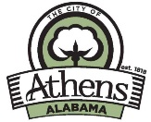

**MEMBERSHIP CREDENTIALS**

**Alabama Network of Family Resource Centers**

ALCFRC has been a member of Alabama Network of Family Resource Centers (ANFRC) since March 2021. In May 2000, the Alabama State Legislature passed into law the 25 standards for Alabama family resource centers (Section 31-8-2, code of Alabama 1975). This major milestone protects the integrity of the Alabama’s family resource center model and ensures the highest quality of service for Alabama families. Each of the 25 standards is specific and measurable and ensures that the highest quality of service is available to those families seeking assistance from a member site. Membership in the ANFRC is based on proven implementation and maintenance of each of the 25 standards. As a full member, ALCFRC must periodically resubmit an ANFRC application to ensure continued attainment of membership standards. Our next recertification is May 2025. Membership in ANFRC is further evidence that we provide impeccable services for our Athens-Limestone County residents. In addition, membership has led to us receiving Workforce Development Grants (A-RESET and TANF) totaling $115,000 to assist residents with becoming gainfully employed. Lastly, we have received a $10,550 Alabama Board of Education-Circle of Care pass-through grant to focus on child mentoring.

**PROGRAMS**

**Family Solutions Program (FSP)**

The Family Solutions Program (FSP) is funded by the United Way of Limestone County as well as local churches. FSP has a goal of helping families and individuals in unsustainable situations by putting them on a path towards sustainability and success. We help lower income families and individuals financially by assisting with rent and utility payments. We then create a simple plan for success that is achievable. This is with resource referrals that are specific to their situation. Our participants must also attend a financial management class taught by representatives from the following local banks: Regions Bank, Redstone Federal Credit Union, Listerhill Federal Credit Union, Trustmark Bank and Bank Independent. These industry experts provide instruction focusing on proper budgeting and spending. The goal is that this instruction will positively influence our clients’ spending and saving habits and prevent them from needing this service in the future.

After our clients have attended the class and assistance has been granted, we check in with our clients to see if they are well on their way to achieving their financial goals. Our participant follow-up system allows us to see how the participant is progressing and allows us to give further guidance and counseling if needed. In 2023, we served 1030 FSP clients assisting them with over $38,000 in rent and utilities payments.

**FSP Success Stories**

1. FSP was able to assist a family who had multiple children from losing their home and aided with appropriate guidance on their financials moving forward.
2. FSP assisted a young lady, who was in her late to early teens, with rental assistance. She was starting out on her own for the first time. She was connected to Workforce Development, to give her the opportunity to break family generational cycles.

**

The Workforce Development Program was launched in October 2022 with the goal to serve at least 50 clients. The goal is to serve individuals in Limestone County that need assistance with removing barriers that might prevent them from reaching their professional goals in life. We focus on the individual clients and how to best serve them. Each client is given a needs assessment. We partner with other resources to assist with education, work readiness, and financial assistance. Funding comes from A-RESET, TANF, and Arby’s (Inspire Foundation) to serve Limestone County residents between the ages of 16 to 59 years of age.

Initial focus was on public awareness to reach out to the community and let them know that the program exists and is ready to serve the community. The current focus is to grow the program and provide resources to the community. We aim to continue to work with participants to assist in developing their job skills.

We teach skills that everyone should have before completing the program. The goal is to give participants the ability to create a resume and keep it updated, complete a job application, have the confidence to present themselves well in a job interview, and understand professional soft skills.

Having a successful Workforce Development Program requires collaboration with other Limestone County community service organizations. Calhoun Community College has partnered with us to assist our individuals with Adult Education, MAPS, and ACES. We have also partnered with Juvenile Probation in Limestone County to be able to serve those individuals that might need assistance in getting a job or work readiness skills. In the next year, we want to build partnerships with others in the community. This would include businesses from different industries that will assist in finding positions for the program participants. This would allow our participants to work toward a goal of finding a career that will be sustainable for themselves and their families.

**WFD Success Story**

In 2023, there was a young single mother that joined the ARESET program and began working with the coordinator. She was facing many barriers and seemed to struggle with maintaining focus on goals that she had for herself. She ended up taking a brief break from the program but came back and she had a renewed determination. Being a single mother, one barrier that she had was the limited support from her family. She and the coordinator began working on participant’s goals and ways to overcome her barriers. Participant began working towards earning certificates to work in the healthcare field. As of today, she has earned one of the four that she is working towards. She currently has a possible job for when she receives all the certificates, which will allow her to start making $19.00 an hour, and she can provide for her family

**Family Ramp Program**

The Family Ramp Program is designed to help homebound residents acquire or maintain mobility. Access to wheelchair ramps improves quality of life and permits independence for these residents. We receive funding from local churches, community residents and TARCOG. Thankfully, the cost of materials has begun to decline some this year. We have a new Ramp Program Coordinator. Since shifting from volunteer to employee she has updated guidelines and assessments and has also added four (4) new volunteer teams to our line-up.

**Program Essentials:**

* Ramp assistance minimizes hazards which could result in physical harm.
* Ramps improve quality of life through the ability to be mobile and/or independent.
* We provide complete wheelchair ramp & rail installation for residents who qualify. This includes material and construction.
* For residents who do not qualify for monetary assistance, we provide standards and specifications for self-installation.

|  |  |  |  |  |
| --- | --- | --- | --- | --- |
| **FAMILY RAMP PROGRAM** | | | | |
|  | **July 2021-June 2022** | **July 2022-June 2023** | | **July 2023-June 2024** |
| Material Cost | $25,293.72 | $20,954.27 | | $12,005.06 |
| Ramps Completed | 27 | 25 | | 20 |
| Home Assessments | 33 | 31 | | 22 |
| Phone Assessments | 42 | 43 | | 25 |
| **JULY 2023 TO JUNE 2024** | | | | |
| 8 Teams from 8 Churches | | | | 167 Ramp Volunteers | |
| 778.5 Volunteer Hours | | | | 20 Ramps Built | |

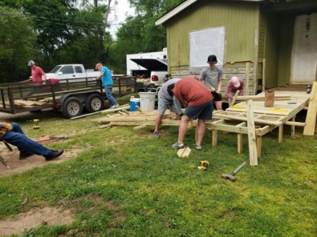

**Family Ramp Success Story**

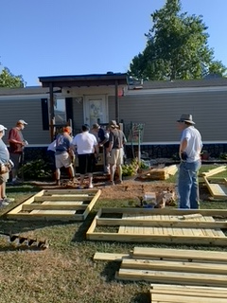A middle-aged man with four children had a car accident that left him a quadriplegic.  The wife did not even have a way to get him to the doctor.  A ramp was built by a local church.  This allowed him not only to get to the doctor but also out in the community and his children’s events.  A bonus to this story is that, with the ramp being built, the neighborhood and the building team’s church took the initiative to further help the family in many other ways. This family was new to the area and were amazed by the outpouring of help that they received.  In addition, the community was blessed by being able to help.

**Dolly Parton Imagination Library**

On July 12, 2023, ALCFRC became the Limestone County hub for Dolly Parton’s Imagination Library (DPIL). This program is a book gifting program that mails free, high-quality books to children from birth to age five. DPIL has received honors and awards for their dedication to enriching the lives of children everywhere. The Good Housekeeping Seal of Approval, Best Practices award from the Library of Congress Literacy Awards and recognition in Reading Psychology are just a few among a long list of the prestigious acknowledgements the program has received. We are very excited to add DPIL to our list of services for Limestone County families.

Project Smile provides school-based mentoring relationships for children kindergarten – 5th grade who often have interfering, hindering or disruptive behaviors in the classroom. Each child will receive an age-appropriate lesson that focuses on coping skills, life skills, and redirecting behavior in and out of the classroom. The lessons also have activities to go along with them, these activities are anything from breathing techniques or making a replica of the spot with play doh. Mentors (employees of ALCFRC) w meet with children in a group and/or individual setting each week to discuss a lesson. These lessons are designed to help students recognize their sadness, anger, or worry feelings, and find the place of peacefulness. Project Smile has completed the first year in 5 schools in Limestone County and Athens City, serving a total of 22 students.

**Project Smile Success Story**

One of the students that participated in Project Smile through the school wanted to continue through the summer. The child’s father reached out to inform that his child had used the techniques and shared that with his own father. The child was able to talk through emotions and breathing techniques to help calm down. As a result, he is able to focus on the instruction given in class and the teacher can assist other students more efficiently.

**Project Game Changers**

Project Game Changers is a school-based mentoring program providing after school activities for 6th – 12th grade students to promote healthy self-esteem, confidence building, and a stable environment during hours when youth tend to get off track. The program will also deter problematic behavior that can lend to delinquency, dropping out of school, and running away. This year, Project Game Changers was offered to a group of 6th-8th graders at Athens Renaissance. Students learned about what self-esteem and how things in their lives can and do affect it, such as family, friends, school, social media, bullying (in-person and online), the future, and mental health. During these sessions, the students learned about skills they could each use to build themselves up and increase their healthy self-esteem.

**Family Assistance Through Community Ties (FACT)**

In February 2024, Athens Limestone County Family Resource Center was awarded a grant to further assist families in Limestone County. This grant allows our center to work with Athens City and Limestone County schools to assist in providing resources to the students and families. The center assists the families in their needs, whether it is with Family Solutions for rent or utility assistance or Workforce Development because a parent is unemployed or underemployed. When families are facing barriers, it can affect the children in the home, and one way it does this is through their school participation. If families can be assisted through FACT, then the hope is that the family and the student can continue to succeed.

**Participant Services**

In addition to the programs, there are other services that ALCFRC offers.

* **Shepherd’s Closet** is full-service clothes closet open to any resident of Limestone County that needs its services. The closet has household items and essential hygiene items as well. Caring Limestone County residents, **Walmart** and other local businesses donate to ALCFRC on a regular basis as does **Bombas** who donates socks, t-shirts, and undergarments.
* ALCFRC has provided **Military Blankets** forhomeless Limestone County residents since 2020. We have increased our request for blankets every year, starting at 60 in 2020 and this year we have requested 150. We are grateful to the **Defense Logistics Agency** in Philadelphia, PA for donating these blankets providing warmth and care to some of our most vulnerable residents.
* Families are also served through our Thanksgiving and Christmas programs. What we can do varies year-to-year, but serving our vulnerable residents with food at thanksgiving and food and toys for kids at Christmas remains constant. **Walmart, Publix, and Panera Bread** are frequent donors for these and our emergency services program. We are currently formulating plans for the 2023 holiday season.



**Our Volunteers**

ALCFRC has many dedicated volunteers, program interns, and community service participants who are an essential part of this agency’s effort. Volunteers operate the Shepherd’s Closet, provide pastoral and financial counseling, build ramps in the Family Ramp Program, conduct repairs and maintenance of ALCFRC, perform general clerical duties, and custodial functions.

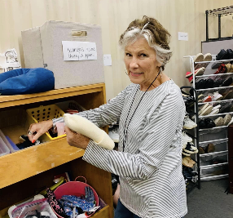

We are so thankful for Crisis Services of North Alabama, our partner agency that also serves our Limestone County residents in our facility. We work together as a team even though we maintain separate entities with unique missions.

**Board of Directors**

Below is a roster of our dedicated board members and the committees in which they serve. The Board of Directors meets quarterly.

|  |  |  |  |
| --- | --- | --- | --- |
| **Board Member** | **Position** | **Committee** | **Serving Since….** |
| Mark Maclin | President | (Oversees all) | 2021 |
| Jackie Brown | Vice-President | Fund-Raising/Marketing | 2021 |
| Tiffany Malone | Secretary | Governance | 2021 |
| Jacob Magnusson | Treasurer | Finance | 2019 |
| Gina Garth |  | Programs | 2024 |
| Debbie Wilson |  | Programs | 2008 |
| Larry Keenum |  | Fundraising/Marketing | 2017 |
| Jannifer Matthews |  | Fund-Raising/Marketing | 2024 |
| Joe Curtis |  | Governance | 2016 |
| AL Rep. Danny Crawford |  | Finance / Governance | 2023 |